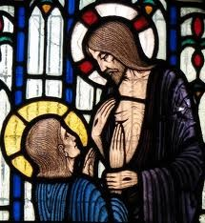
R
St Thomas the Apostle

Phone: 03 5998 0947
0407 085 532
E-mail: denisobryan13@gmail.com
Parish Office: 50 Heather Grove, Cranbourne East.
PO Box 6089, Clyde, Vic, 3978

Catholic Parish, Clyde North

28th April 2020

Dear Parishioners,
Grace and peace to you all in this testing time.
Pope Francis wrote to us last Saturday about the coming month of May. He reminded us that the month of May is a time when the People of God express with particular intensity their love and devotion for the Blessed Virgin Mary. It is also traditional in this month to pray the Rosary at home within the family.
We are encouraged by Pope Francis to rediscover the beauty of praying the Rosary at home in the month of May, either together or individually. There are also two prayers to Our Lady which can be recited at the end of the Rosary. These prayers are available to all through our parish web page.
On this coming Friday, 1st May, and on each coming Friday, I invite you to join me in a Holy Hour commencing at 7.00pm including the praying of the Rosary and Adoration of the Blessed Sacrament. This will be streamed live on our parish Facebook page at www.facebook.com/stthomasap
Pope Francis finally adds, “Dear brothers and sisters, contemplating the face of Christ with the heart of Mary our Mother, will make us even more united as a spiritual family and will help us overcome this time of trial.” Pope Francis also urges us to pray for him as he does for us.
As I was growing up at home, our family prayed the Rosary together every evening, and I know that many of you have the same memory. It has become for me and for many of us a very beloved prayer. Let us cherish and deepen this tradition of prayer in May this year.
May God bless us all. St Thomas the Apostle, pray for us.
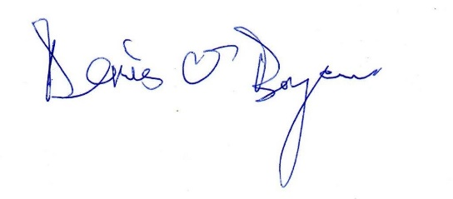
Fr Denis O’Bryan
Parish Priest

