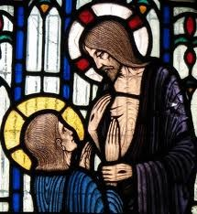
22nd R
St Thomas the Apostle

Phone: 03 5998 0947
0407 085 532
E-mail: denisobryan13@gmail.com
Parish Office: 50 Heather Grove, Cranbourne East.
PO Box 6089, Clyde, Vic, 3978

Catholic Parish, Clyde North

24th April 2020

Dear Parishioners,

Grace and peace be with you.
Archbishop-elect O’Regan has written to inform us that he will be leaving the Sale Diocese early in May and that he will be installed as the Archbishop of Adelaide on Monday 25th May. This year the Feast of Our Lady Help of Christians falls on 25th May.
I ask you to join with me in praying for Archbishop-elect O’Regan in gratitude for the blessings we have enjoyed through his leadership, his ministry and humble presence among us as our bishop. He is arriving in Adelaide at a time when so much of our daily life is altered because of the Covid 19 pandemic, and so we pray that God will bless him with every gift he requires upon his arrival there.
This will begin a new period for our Diocese of awaiting the appointment of a new bishop. Waiting for a new bishop is something to which we have grown accustomed in recent years in our Diocese, and again it’s a time for prayer, praying for a new bishop to be chosen, and praying for those who will administer the Diocese in the interim.
Waiting at home is a feature of our lives at present as our nation strives to restrict the spread of the Covid 19 Coronavirus. It is testing individuals and families. It is calling all of us to make sacrifices.
As we commemorate ANZAC Day this Saturday let us take courage from the dedication and sacrifices made by millions of Australian and New Zealand Defence Force members over more than a hundred years. The names of over 102 000 Australians who have lost their lives in serving their nation in times of conflict are engraved in the Roll of Honour at the Australian War Memorial in Canberra. We remember and pray for them and for all who suffer because of war, tragically still in many places today.
Within our diocese and parish, as everywhere, our normal life has been severely disrupted and many of our usual celebrations are being deferred to a later date. The Chrism Mass with our bishop, when the Holy Oils are blessed in Holy Week, has not yet been celebrated. Weddings and baptisms have been deferred. Our celebration of First Reconciliation has been deferred, although the preparation for the sacrament has been completed.
At this time, we would usually have begun preparation with candidates and families for the Sacrament of Confirmation. Whilst we are not yet able to commence the preparation for Confirmation I would ask every family who has a Confirmation candidate to please register with St Thomas the Apostle Primary School or with Fiona at the parish office by email (Clydenorth.Secretary2@cdsale.org.au) as soon as possible so that we are able to communicate with you directly.
Our Easter season is marked by joy, a joy that leaps from the pages of the Gospel accounts of the resurrection and the subsequent encounters between the disciples and the risen Jesus. Certainly, in these times of trial, our joy is tinged by deep seriousness and the difficult realities which we are now enduring. But the Easter joy is no less real for we know that the light of the risen Jesus shines on us. The forces of evil and death do not have the power to tear us away from the one who loves us and who poured out his blood for our redemption. As St Paul reminds us, “Nothing can separate us from the love of God in Christ Jesus our Lord.” (Romans 8:38-39)

May God bless us all. St Thomas the Apostle, pray for us.

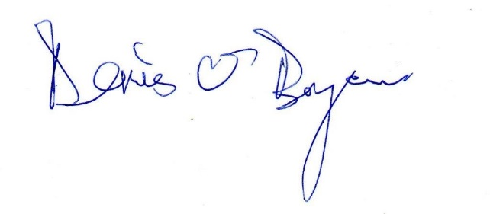

Fr Denis O’Bryan
(Parish Priest)

