25th February 2022

Dear Sisters and Brothers in Christ

O God, author and lover of peace,
To know you is to live, to serve you is to reign;
Defend against every attack those who cry to you,
So that we, who trust in your protection,
Amy not fear the weapons of any foe.
(Collect, In Time of War, Missal pg. 1363)

As we awake this morning, we are confronted with further reports emerging from Ukraine. We share the sense of deep sadness, dismay and fear for the people of Ukraine as President Putin commands his forces to commence their violent assault across many fronts. In a period of history when communication is accessible, we receive, almost immediately, the images of destruction, turmoil, harm and death. We hear, as the psalmist says, “the cry of the poor” (Psalm 34) and wonder how this will end against the might of the adversary.
As we approach the weekend and the days ahead, we will wonder “what can we do?”. I know from Bishop Mykola Bychok CSsR, Eparch for Ukrainian Catholics in Australia, New Zealand and Oceania, how important our solidarity in prayer and peaceful witness is to him and his community. We continue to learn how the people of Ukraine have suffered over many decades and that many have been persecuted for their witness to their faith in the Lord.
No doubt you will have your own creative and imaginative liturgical response to drawing your people into prayerful solidarity, which may include:
- Dedicated periods of prayer;
- Pope Francis has called for a World Day of Fasting and Prayer for the people of Ukraine on 2 March 2022 which will give impetus to our Lenten journey;
- You might consider a liturgical action: lighting of tapers; a reflective Penitential Rite; Particular use of Ritual Masses, Eucharistic Prayers for Reconciliation and Special Needs;
- Your community may wish messages of peace to our Ukrainian Catholic Community, Eparchy of Saints Peter and Paul, 35 Canning Street, North Melbourne;
- Join with our ecumenical and interfaith gatherings for peace.
We are mindful of our pastoral care and attention of many in our communities who have found a new home in Australia following persecution, war and violence. This particular moment of history now sets in motion a sense of fear, turmoil and anxiety which unsettles all nations and peoples.
We place our hope in the God who is with us and whose Son is the true Prince of Peace. May our solidarity in faith, with people of good, transform this darkness with the power of Christ the Light.
Even more, by your Spirit you move human hearts
That enemies may speak to each other again,
Adversaries join hands,
And people seek to meet together.
By the working of your power
It comes about, O Lord,
That hatred is overcome by love,
Revenge gives way to forgiveness
And discord changed by mutual respect.
(Eucharistic Prayer for Reconciliation II)

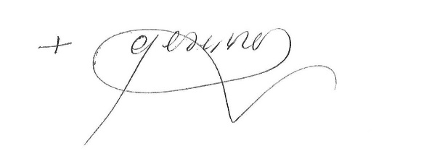
We place our prayers through the intercession of Our Lady of Perpetual Help,

Bishop Greg Bennet
Bishop of Sale

2

