Groups and Meetings
BAPTISM PREPARATION: 1st Sunday of the month 2.00pm for more information or registration call the Parish Office or visit our website.
MARRIAGES: At least 6 months’ notice. Call the Parish Office
RCIA: For adults interested to join the Catholic Faith. Classes to begin soon. For enquiries, contact Ruth Marais on 0430 716 664.
SACRAMENT FOR SCHOOL AGED CHILDREN (1st Reconciliation, 1st Holy Communion & Confirmation) :
Email parishofstthomasap@gmail.com
LITTLE FRIENDS OF JESUS – teaching of the catholic faith to children from Prep – Gr 6. Every Saturday (school term) email: friendsofjesussttap@gmail.com
YOUNG ADULT GROUP: Ages: 18-35 years. For enquiries, please contact the Parish Office.
ST VINNIES PHONE ROOM – if you or someone you know need assistance from St Vinnies, please call 5995 0211.

Mass Intentions  Saturday (25/11) 6.00pm : Repose of the souls of Leena Pinto & Arun D’Costa  Sunday (26/11) 9.00am : People of the parish  10.45am : Repose of the souls of Wilfred & Anna Peres & June & Theodore Aldonis  Monday (27/11) : No Mass  Tuesday (28/11) 8.00am : Repose of the souls of Andrews & Murray families  Wednesday (29/11) : Repose of the souls of families, friends & benefactors of Mary & Anderw Schulberg  Thursday (30/11) 8.00am : Repose of the soul of Frank & Lise Donaldson  Friday (1/12) : Repose of the soul of Annie Meneaud  Saturday (2/12) : Repose of the souls of family & friends of the Pantorno family  Pray for the sick: : Fr Bernard Buckley, Luicile Noel, Sue Dower, Salvador Guidos, Albert Hartung, Greg Recalde, Carol Vincenz, Baby De’andre Hooft, Anura Fernando, Ross Smith, Clermont Ignace, John Stray, Ben Kerr, Gillian Apollon, Carmen Vella  Recently deceased : Elma Lim, Sheldon Widrose, Roland Williams  Death Anniv/Remb : Princy Fernando, Iris Wickremasinghe |  | Parish Council Members:  Fr Denis, Dcn Michael, Jonathan Rubite, Sandra Ignace, Dezlene Orchard, Jerusha Benjamin,  Parish Finance Members: Fr Denis, Sinclair Thomas, Patrick Ross, Helene Jayamaha, Peter Gomez, Heidi Keel, Ruwan Kumaraperu

Next week’s readings: Is 63:16-17,64:1,3-8 1 Cor 1:3-9 Mk 13:33-37

New Parishioner Registration
Please register online at https://stthomasap.org.au/new-parishioner-registration/
OR pick up a form from our worship space OR call the Parish Office

SUNDAY ACTIVITY (more activity sheets for children, teens and young adults available in the foyer)
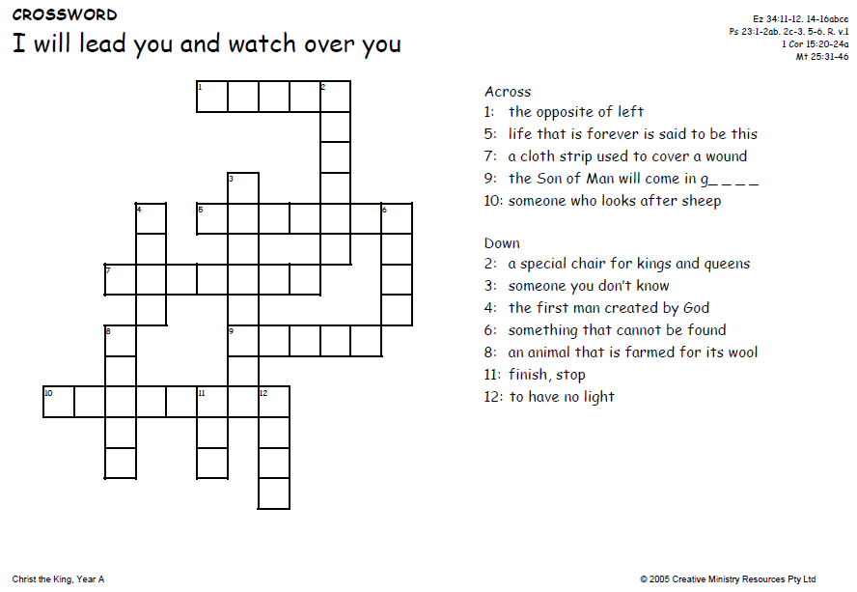
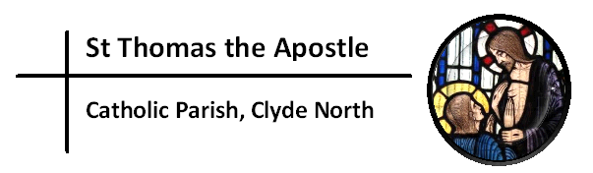
“My Lord and My God!”
Church & Parish Office: 5 Fiorelli Blvd, Cranbourne East 3977
Mailing address: PO Box 6089, Clyde VIC 3978
Parish Priest: Fr Denis O’Bryan Presbytery Phone: 5999 0059 (After office hours emergency)
Deacon: Michael Manuel Email: Michael.Manuel@cdsale.org.au
Parish Office Hours: Tuesday – Friday 9.00am – 3.00pm
Parish Office Phone: 5998 0947
Email: parish@stthomasap.org.au Website: www.stthomasap.org.au www.facebook.com/stthomasap
Pastoral Associate: Sr Juliana Ogbole Email: Clydenorth.pastoralassociate@cdsale.org.au
Parish Secretaries: Christine Salu Email: parish@stthomasap.org.au
Fiona Goh Email: Clydenorth.Secretary2@cdsale.org.au
Parish Safeguarding Officer: Ann Rode (Wednesday 9.00am – 3.00pm)
Email: Clydenorth.Safety@cdsale.org.au
WELCOME TO OUR MASS
CHRIST THE KING (Year A) – 26th November 2023
Masses & Reconciliation Times |  |  | Parish Schools
MASS CELEBRATED AT 5 FIORELLI BLVD CRANBOURNE EAST  Sunday Masses  Saturday Vigil: 6pm  Sunday: 9am, 10.45am  Weekday Masses (week of 20th Nov – 25th Nov)  Monday: No Mass  Tuesday & Thursday: 8.00am  Wednesday, Friday & Saturday: 9.30am  Praying of the Holy Rosary after morning Mass  Feast day:  Thur 30th Nov – St Andrew, Apostle  ADVENT PARISH RECONCILIATION  Wednesday 20th Dec @ 7pm | Baptism  Baptism Preparation 1st Sunday every month.  Sacrament of Baptism most Sundays.  Reconciliation  Every Saturday between 5.30pm to 5.45pm.  Blessed Sacrament  Exposition of the Blessed Sacrament Every Friday after morning Mass to 7pm |  | St Thomas the Apostle Primary School  5 Fiorelli Boulevard,  Cranbourne East  Phone: 5998 9293  Principal: Mrs Kate Dourley  St Peter’s Secondary College  (Clyde North Campus)  55 MacKillop Way, Clyde North  Phone: 5990 7777  Principal: Mr Chris Black
Prayer of Saint Thomas the Apostle
Glorious Saint Thomas, Your love for Jesus, and faith in Him as your Lord and God, are an inspiration for all who seek Jesus. You gave up your life for Him as an Apostle, and as a missionary. You encourage us to be courageous in giving witness to our faith and in proclaiming the Gospel. You lead us to be missionary in our endeavours. As our patron, pray for us as we build a new Catholic Church in Clyde North. We ask your intercession that we may spend ourselves in the service of Jesus and His mission. Under your watchful care may we grow in faith, and generously use our talents, gifts and vision in the service of Christ Jesus, and in love for our neighbour. St Thomas the Apostle Pray For Us

First Reading Ez 34:11-12,15-17
The Lord will judge between sheep and sheep

The Word of the Lord
Responsorial Psalm Psalm 22(23):1-3a,5-6
R. The Lord is my shepherd; there is nothing I shall want.

The Lord is my shepherd;  there is nothing I shall want.  Fresh and green are the pastures  where he gives me repose. R.  Near restful waters he leads me,  to revive my drooping spirit.  He guides me along the right path;  he is true to his name. R. | You have prepared a banquet for me  in the sight of my foes.  My head you have anointed with oil;  my cup is overflowing. R.  Surely goodness and kindness shall follow me  all the days of my life.  In the Lord’s own house shall I dwell  for ever and ever. R.
Second Reading 1 Co 15:20-26,28
Christ will hand over the kingdom to God the Father; so that God may be all in all

The Word of the Lord
Gospel Acclamation
Alleluia, alleluia! Blessing on him, who comes in the name of the Lord! Blessings on the coming kingdom of our father David! Alleluia!
Gospel Mt 25:31-46
I was naked and you clothed me; sick, and you visited me

Jesus said to his disciples: ‘When the Son of Man comes in his glory, escorted by all the angels, then he will take his seat on his throne of glory. All the nations will be assembled before him and he will separate men one from another as the shepherd separates sheep from goats. He will place the sheep on his right hand and the goats on his left.
‘Then the King will say to those on his right hand, “Come, you whom my Father has blessed, take for your heritage the kingdom prepared for you since the foundation of the world. For I was hungry and you gave me food; I was thirsty and you gave me drink; I was a stranger and you made me welcome; naked and you clothed me, sick and you visited me, in prison and you came to see me.” Then the virtuous will say to him in reply, “Lord, when did we see you hungry and feed you; or thirsty and give you drink? When did we see you a stranger and make you welcome; naked and clothe you; sick or in prison and go to see you?” And the King will answer, “I tell you solemnly, in so far as you did this to one of the least of these brothers of mine, you did it to me.”
‘Next he will say to those on his left hand, “Go away from me, with your curse upon you, to the eternal fire prepared for the devil and his angels. For I was hungry and you never gave me food; I was thirsty and you never gave me anything to drink; I was a stranger and you never made me welcome, naked and you never clothed me, sick and in prison and you never visited me.” Then it will be their turn to ask, “Lord, when did we see you hungry or thirsty, a stranger or naked, sick or in prison, and did not come to your help?” Then he will answer, “I tell you solemnly, in so far as you neglected to do this to one of the least of these, you neglected to do it to me.”
‘And they will go away to eternal punishment, and the virtuous to eternal life.’
The Gospel of the Lord.
Memorial Acclamation
Save us, Saviour of the world, for by your Cross & Resurrection you have set us free.

NEW, RELOCATING or LEAVING THE PARISH?  New Parishioners – please register @ https://stthomasap.org.au/new-parishioner-registration/ Relocating or Leaving Parishioners – please call the parish office | CHURCH BUILDING DONATION  via donation envelope or https://stthomasap.org.au/donate/ or EFTPOS. Donations are not tax deductable.
SAFEGUARDING – Please do not leave children unsupervised in the church and in the toilets. Our parish is committed to providing a safe and supportive environment for all people with special concern for children, young people and adults at risk. Our Safeguarding Office, Ann Rode, can be contacted via email: clydenorth.safety@cdsale.org.au or call 5998 0947

NOTICES
ADVENT PARISH RECONCILIATION – Our whole parish reconciliation is on Wednesday 20th Dec. Other parishes Advent Reconciliation dates are : Wed 13th Dec St Patrick, Pakenham. Tue 19th Dec Our Lady Help of Christians, Narre Warren. Thur 21st Dec St Agatha’s, Cranbourne. All reconciliation is at 7pm.
CHRISTMAS & NEW YEAR’S DAY MASS TIMES:
Christmas Eve 24th Dec – 7pm
Christmas Day 25th Dec – Midnight, 9am & 10.45am
New Year’s Eve 31st Dec – 7pm
New Year’s Day 1st Jan – 10am
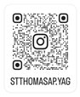
YOUNG ADULTS GROUP (YAG) for 18-35 YEARS: We are now on Instagram stthomasap.yag
Scan the QR code if you would like to follow us for updates & upcoming events.
YAG CHRISTMAS PARTY! With food, fun and fellowship on Sunday 3rd Dec at 6pm. For catering purpose, book with QR Code or this link https://www.trybooking.com/CNOVO. New members welcomed. For enquiries, please contact the parish office.
CAROLS NIGHT - The Parish Christmas Carols Night will be held on Saturday, 9th Dec from 6.00 pm (Saturday evening Mass on that day is at 5pm) at the St. Thomas car park / basketball court. We invite our parishioners and their families & friends to come and participate in the celebration of “A Festival of Nine Lessons & Carols” with the various choir groups of the parish. This will be a fun filled night with food and drinks available for purchase on the evening. For logistic purpose, please scan QR Code. Please bring along your chairs, mats and rugs and enjoy the festivities. Let us celebrate Christmas together!
EXPRESSION OF INTEREST FOR SACRAMENTS IN 2024 – Families of children preparing for the Sacraments of Reconciliation, Holy Communion &/or Confirmation in 2024 in this parish, please complete the form with the QR code or this link https://forms.office.com/r/M1w8iT0rvt to express your interest. Closing date: 22nd Dec

VINNIES CHRISTMAS TOY APPEAL - The Christmas toy appeal aims to collect toys for ages 0 - 14 years which volunteers from Vinnies will distribute to needy families. Help bring a smile to a child’s face this Christmas. Collection boxes will be available in the foyer from this weekend till Sunday, 17th Dec.
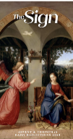
ADVENT & CHRISTMAS 2023 REFLECTION BOOKLET – For those who seek to deepen their faith, foster a sense of contemplation, or simply embrace the beauty of everything that Advent and Christmas brings, The Sign leads you through these sacred stories that continue to resonate throughout the ages. The Sign also features beautiful religious artworks with reflections on the art written by Mons. Graham Schmitzer. On sale from this weekend @ $5 per book! cash preferred.
SHINE A LIGHT ON DOMESTIC VIOLENCE – information on the Catholic Church’s teaching on Separation, Divorce & Annulment pamphlet is available in the church foyer. Please take home a copy or visit www.cdsale.org.au/tribunal or ring 03 5622 6600
DONATIONS TO THE CHURCH – TAP POINT TERMINALS: Terminals are in the foyer on the on the table under the painting of Our Lady. Please note that these donations are NOT combined with the Planned Giving Stewardship donations. To join or donate to the Planned Giving Stewardship Program please contact the parish office.
ST VINNIES FOOD BIN – if you’d like to help those in the community that are doing it tough, the St Vinnies Food bin in the foyer is available for you to donate non-perishable food. Thank you.
ADORATION CHAPEL - Exposition of the Blessed Sacrament every Friday after morning Mass till 7pm. For code to access the chapel, please contact the office on 5998 0947 or parish@stthomasap.org.au
AUSTRALIAN NATIVITY SCENE
The annual Australian Nativity Scene (ANS) celebrates 20 years and a big thank you to Fr. Tad, parishioners and well-wishers from all over, who have been supporting this event year after year. The public display opens on 4th December 2023 and concludes on 12th January 2024. Family, friends and groups are invited to view this display before and after the mass, or any other time by prior appointments only. Contact Parish office on 9795 6217 or Wilson on 0428 927 110 for a personalised tour. For more details, visit: www.australiannativityscene.org
The nativity scene has a weekly story
- Mary and Joseph in Bethlehem
- They find a place to live in a stable
- Jesus is born
- The angel conveys the good news to the shepherd followed by adoration
- The three kings or wise men are in town
- The three kings visit baby Jesus; and the last week concludes with
- Jesus is safe and the holy family flees to Egypt
To mark the 20th Anniversary, Archbishop Peter A Comensoli would be celebrating the Vigil Mass on the first Sunday of Advent followed by light refreshments. The details are as below:
When: Saturday, 2 December; 6.30 PM
Where: St. Elizabeth’s Parish, Dandenong North
So, please join us with family and friends. Thank you.
CATHOLIC RESOURCES: formed.org (get free access password from the parish office), shalomworld.org, EWTN.org, aleteia.org

We kindly ask that you keep the house of GOD clean. No Food & Drinks in the Church and check that you did not leave any belongings behind before leaving Church.

\fdfdfdfdfdfdfdfdfListening and Discernment
The Plenary Council National Team is continuing working on this phase to present it to all parishes in Australia. We pray to the Spirit of
God to help with this preparation upholding the people of this country in his heart. www.plenarycouncil.com.au
Diocesan Pilgrimage held this week at St Ita’s Catholic Church in
Drouin
SALE DIOCESAN ASSEMBLY - 13
th
& 14
th
SEPTEMBER 2019
We invite all parishioners to join in a parish discussion and share your thoughts on the Themes for the Diocesan Assembly. Our parish
offers four ways in which we can join in the conversation:
1. Coming together on Monday 2
nd
of September at 7.30 pm – St Peter’s College. This main session is for Delegates attending the
Diocesan Assembly but also open to parishioners.
2. You might also wish to discuss the themes in small groups at home, with family and friends or in your prayer groups and submit your
thoughts online.
3. You may also send in your own personal submission online following the steps on the Diocese website.
4. Alternatively, you may wish to write your responses filling in your comments about a particular Assembly theme on the feedback form
called: “Share your thoughts with us! What would a parish living the joy of the gospel look like?” Copies of
this form are placed at the entrance tables. Please fill it in, bring your response to Mass and post it into the Parish Office Box placed
at the entrance table also.

All personal & group responses can be submitted to our Diocese website before the 9
th
September
The discussion kit is available from the Diocesan website
Diocese website : https://www.cdsale.org.au/news/
DIOCESAN ASSEMBLY THEMES
Reflecting on a theme: what would a parish living the joy of the Gospel be
like?
Theme 1: Faith Formation & Spirituality, which involves • Faith Formation for adults • Faith formation for children and young people •
Sacramental Preparation • RCIA • Understanding Church Teaching • Prayer life
Theme 2: Leadership & Governance (providing leadership & structures that promote evangelisation) • National/diocesan/parish
structures • Finance matters • Parish Pastoral Councils • Ongoing support, mentoring and professional development of leaders and staff
• Pastoral Planning • Communication • Roles – priests, religious, laity.
Theme 3: Families and Vocation (raising disciples in our families - so that they can go out into the world) • Supporting family life in all
its diversity • Supporting married couples • Supporting young people/young adults • Vocations.
Theme 4: Liturgy and Prayer (nourishing our communities) • Music • Homilies • Liturgical formation for parish communities and liturgy
teams • Liturgies, other than Sunday Eucharist • A variety of prayer experiences
Theme 5: The Welcoming Community (a community on mission, not maintenance) • Building a welcoming community • Pastoral care •
Reaching out to those on the margins (divorced and remarried, gay community, those with disabilities) • Reaching out to those who have
left the church (resting Catholics) • Strategies for growing parishes • Caring for those affected by the sexual abuse crisis
All personal & group responses can be submitted to our Diocese before the 9
th
September
Diocese website : https://www.cdsale.org.au/news/
We thank you for your time and your thoughts. May God bless you!

