Groups and Meetings
BAPTISM PREPARATION: 1st Sunday of the month 2.00pm for more information or registration call the Parish Office or visit our website.
MARRIAGES: At least 6 months’ notice. Call the Parish Office
RCIA: For adults interested to join the Catholic Faith. Classes to begin soon. For enquiries, contact Ruth Marais on 0430 716 664.
SACRAMENT FOR SCHOOL AGED CHILDREN (1st Reconciliation, 1st Holy Communion & Confirmation) :
Email parishofstthomasap@gmail.com
LITTLE FRIENDS OF JESUS – teaching of the catholic faith to children from Prep – Gr 6. Every Saturday (school term) email: friendsofjesussttap@gmail.com
YOUNG ADULT GROUP: Ages: 18-35 years. For enquiries, please contact the Parish Office.
ST VINNIES PHONE ROOM – if you or someone you know need assistance from St Vinnies, please call 5995 0211.

Mass Intentions  Saturday (20/1) 6.00pm : People of the parish  Sunday (21/1) 9.00am : Repose of the souls of families & friends of the Fynn & Fernandes families  10.45am : Repose of the soul of Frank Borg  Monday (22/1) : No Mass  Tuesday (23/1) : Repose of the souls of family, friends & benefactors of the Nidea family  Wednesday (24/1) : No Mass  Thursday (25/1) : Repose of the souls of family, friends & benefactors of the Samarashingha family  Friday (26/1) : Repose of the souls of family, friends & benefactors of the Manguilin family  Saturday (27/1 ) : B’day Thanksgiving for Teagan Trousse  Pray for the sick: : Fr Bernard Buckley, Luicile Noel, Sue Dower, Salvador Guidos, Albert Hartung, Greg Recalde, Carol Vincenz, Anura Fernando, Ross Smith, Clermont Ignace, John Stray, Ben Kerr, Gillian Apollon, Carmen Vella  Recently deceased : Valarie Mendes, Alice Otobo, Gerty Fernandez, Marie Karunaratne, Giuseppina Mollica, Berndette Hookens, Geraldine Jansen  Death Anniv/Remb : George Quinones Catostos, Frank & Charlotte D’Souza, Bonnie Garrad |  | Parish Council Members:  Fr Denis, Dcn Michael, Jonathan Rubite, Sandra Ignace, Dezlene Orchard, Jerusha Benjamin,  Parish Finance Members: Fr Denis, Sinclair Thomas, Patrick Ross, Helene Jayamaha, Peter Gomez, Heidi Keel, Ruwan Kumaraperu

Next week’s readings: Deu 18:15-20 1Cor7:32-35 Mk 1:21-28

New Parishioner Registration
Please register online at https://stthomasap.org.au/new-parishioner-registration/
OR pick up a form from our worship space OR call the Parish Office

SUNDAY ACTIVITY (more activity sheets for children, teens and young adults available in the foyer)
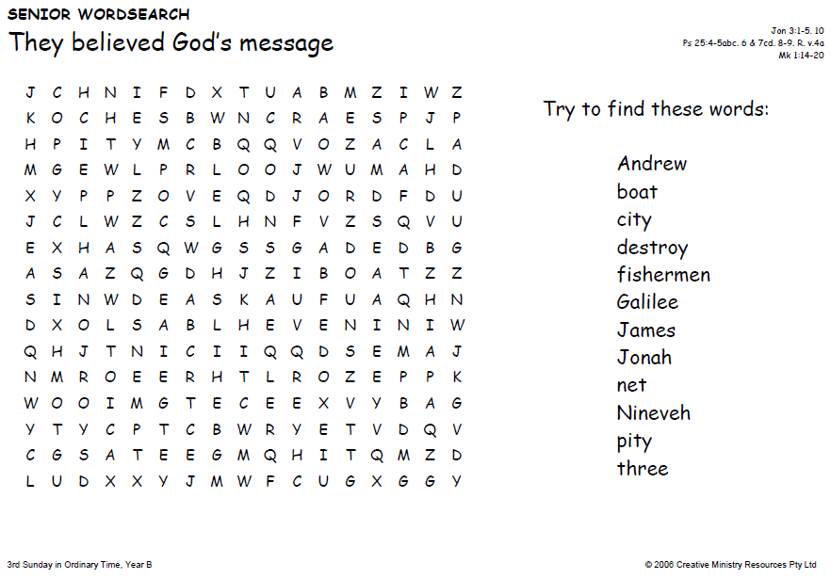
“My Lord and My God!”
Church & Parish Office: 5 Fiorelli Blvd, Cranbourne East 3977
Mailing address: PO Box 6089, Clyde VIC 3978
Parish Priest: Fr Denis O’Bryan Presbytery Phone: 5999 0059 (After office hours emergency)
Assistant Priest: Fr Jithin Anto
Deacon: Michael Manuel Email: Michael.Manuel@cdsale.org.au
Parish Office Hours: Tuesday – Friday 9.00am – 3.00pm
Parish Office Phone: 5998 0947
Email: parish@stthomasap.org.au Website: www.stthomasap.org.au www.facebook.com/stthomasap
Pastoral Associate: Sr Juliana Ogbole Email: Clydenorth.pastoralassociate@cdsale.org.au
Parish Secretaries: Christine Salu Email: parish@stthomasap.org.au
Fiona Goh Email: Clydenorth.Secretary2@cdsale.org.au
Parish Safeguarding Officer: Ann Rode (Wednesday 9.00am – 3.00pm)
Email: Clydenorth.Safety@cdsale.org.au
WELCOME TO OUR MASS
3rd Sunday in Ordinary Timed (Year B) –21st January 2024
Masses & Reconciliation Times |  |  | Parish Schools
MASS CELEBRATED AT 5 FIORELLI BLVD CRANBOURNE EAST  Sunday Masses  Saturday Vigil: 6pm  Sunday: 9am, 10.45am  Weekday Masses (week of 22nd Jan – 27th Jan)  Mon: No Mass  Wed: No Mass (Memorial Mass for the late Alice Otobo, mother of Fr Francis Otobo, at Sale. Details in the bulletin)  Tue, Thur - Sat : 9.30am  Praying of the Holy Rosary after morning Mass  Feast & Memorial DAYS  Mon: St Vincent, Deacon, Martyr  Wed: St Francis de Sales, Bishop, Doctor  Thur: The Conversion of St Paul, Apostle | Baptism  Baptism Preparation 1st Sunday every month.  Sacrament of Baptism most Sundays.  Reconciliation  Every Friday after morning Mass & Saturday between 5.30pm to 5.45pm.  Blessed Sacrament  Exposition of the Blessed Sacrament  everyday except 1 hr before every Mass |  | St Thomas the Apostle Primary School  5 Fiorelli Boulevard,  Cranbourne East  Phone: 5998 9293  Principal: Mrs Kate Dourley  St Peter’s Secondary College  (Clyde North Campus)  55 MacKillop Way, Clyde North  Phone: 5990 7777  Principal: Mr Chris Black
Prayer of Saint Thomas the Apostle
Glorious Saint Thomas, Your love for Jesus, and faith in Him as your Lord and God, are an inspiration for all who seek Jesus. You gave up your life for Him as an Apostle, and as a missionary. You encourage us to be courageous in giving witness to our faith and in proclaiming the Gospel. You lead us to be missionary in our endeavours. As our patron, pray for us as we build a new Catholic Church in Clyde North. We ask your intercession that we may spend ourselves in the service of Jesus and His mission. Under your watchful care may we grow in faith, and generously use our talents, gifts and vision in the service of Christ Jesus, and in love for our neighbour. St Thomas the Apostle Pray For Us
First Reading Jonah 3:1-5,10
The people of Nineveh renounce their evil behaviour

The Word of the Lord
Responsorial Psalm Ps 24(25): 4-6, 7b-9
R. Teach me your ways, O Lord.

Lord, make me know your ways.
Lord, teach me your paths.
Make me walk in your truth, and teach me:
for you are God my saviour.

Remember your mercy, Lord,
and the love you have shown from of old.
In your love remember me,
because of your goodness, O Lord.

The Lord is good and upright.
He shows the path to those who stray,
He guides the humble in the right path,
He teaches his way to the poor.

Second Reading 1 Co 7:29-31
The world as we know it is passing away

The Word of the Lord
Gospel Acclamation
Alleluia, alleluia! The kingdom of God is near: believe the Good News! Alleluia!
Gospel Mk 1:14-20
I will make you into fishers of men

After John had been arrested, Jesus went into Galilee. There he proclaimed the Good News from God. ‘The time has come’ he said ‘and the kingdom of God is close at hand. Repent, and believe the Good News.’
As he was walking along by the Sea of Galilee he saw Simon and his brother Andrew casting a net in the lake – for they were fishermen. And Jesus said to them, ‘Follow me and I will make you into fishers of men.’ And at once they left their nets and followed him.
Going on a little further, he saw James son of Zebedee and his brother John; they too were in their boat, mending their nets. He called them at once and, leaving their father Zebedee in the boat with the men he employed, they went after him.

The Gospel of the Lord.
Memorial Acclamation
When we eat this Bread and drink this Cup, we proclaim your Death, O Lord, until you come again.

NOTICES
WE WELCOME FR JITHIN to St Thomas the Apostle Church. Please join us for a cuppa after all Masses this weekend to meet Fr Jithin & to introduce yourself & you family to our new Assistant Priest.
BOOK SALE – Pre-loved books on sale on 3rd & 4th Feb weekend at all the Masses. Cash preferred.
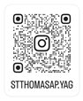
YOUNG ADULTS GROUP (YAG) for 18-35 YEARS: We are now on Instagram stthomasap.yag
2024 is going to be another exciting year ahead for our Young Adult Groups & our Teen Youth Group. Keep watching this space for updates. New members welcomed. For enquiries, please contact the parish office.
FEAST OF THE HOLY ESPOUSAL OF MARY & JOSEPH – This centuries-old feast honoring the union of Mary & Joseph is traditionally celebrated on 23 Jan in different parts of the world. On the weekend of 20th /21st Jan, a prayer (printout provided) & blessing will be given to married couples at all the weekend Masses as we pray for the grace to imitate the Holy Spouses in every marriage in the same way Christ love for his Church.
EXTRA SUNDAY EVENING MASS FROM SUNDAY 18TH FEB 5PM – please do take note of our extra Mass added to Sunday evenings beginning 18th Feb.
SACRAMENT OF RECONCILICATION – the program for this sacrament will commence on 6th Feb, if you have yet to express your interest to enrol your child (baptised & Gr 3 upwards), please send an email to parishofstthomasap@gmail.com
STEWARDSHIP ENVELOPES & RECEIPT – to save the parish postage expense, we are asking our parishioners to help drop-off the uncollected envelopes. They are arranged in street order.
ST VINNIES FOOD BIN – donate non-perishable food to St Vinnies to help those in the community that are in need. St Vinnies Food bin is in the foyer. Thank you for your generous donation.
DONATIONS TO THE CHURCH – TAP POINT TERMINALS: Terminals are in the foyer on the on the table under the painting of Our Lady. Please note that these donations are NOT combined with the Planned Giving Stewardship donations. To join or donate to the Planned Giving Stewardship Program please contact the parish office.
ADORATION CHAPEL - 24 hrs 7 days a week except during Mass and 1 hr before Mass. A new passcode is generated and emailed to those who have registered with the parish office. If you did not receive the email or would like to get a code, please call the office or email: parish@stthomasap.org.au
LEGION OF MARY PRAESIDIUM – Dear parishioners, we would like to start a Legion of Mary Praesidium in our parish. We invite you to be part of this wonderful devotion to Our Holy Mother, which includes prayer and works done in the closest union with Mary and the Holy Spirit. For enquiries or to express your interest, please call Mary on 0432 166 850 or the Parish Office.
ROSARY SESSION ONLINE - St Mary’s Parish Bairnsdale invites you to an online community. Experiencing a spiritual journey praying the Rosary with Mary in contemplation with her son Jesus. Register for this free weekly ZOOM gathering on Monday nights 7pm-7.30pm. Contact Michelle for link at stm.michelleg@gmail.com or 03 5152 2942. Starting 22nd Jan.
VOLUNTEERS REQUIRED TO ASSIST WITH FUNERALS, WEDDINGS & OTHER EVENTS – If you can assist the parish by helping to prepare for these ceremonies including the opening and locking of the church during the day, please contact the parish office to express your interest. Training provided.
MEMORIAL MASS FOR MRS ALICE OTOBO - A memorial Mass for Father Francis Otobo’s late mother, Mrs Alice Otobo who died unexpectedly in Nigeria will be held at St Mary’s Cathedral Sale on Wednesday 24th January 2024 at 11.00am.
CATHOLIC RESOURCES: formed.org (free access password from the parish office), shalomworld.org, EWTN.org, aleteia.org
FREE ONLINE ADVENT RESOURCE 2023 – Listen to the Word from the Sydney Archdiocese. Https//gomakedisciples.org.au/.
JESUIT & IGNATIAN SPIRITUALITY CENTRE – Looking for retreats or spiritual formation? Visit www.jisa.org.au
THE BILLINGS OVULATION METHOD ® - This is a natural method of fertility management. It teaches you to recognise your body’s natural signal of fertility. For more information, go to https://billings.life/en/

NEW, RELOCATING or LEAVING THE PARISH?  New Parishioners – please register @ https://stthomasap.org.au/new-parishioner-registration/ Relocating or Leaving Parishioners – please call the parish office | CHURCH BUILDING DONATION  via donation envelope or https://stthomasap.org.au/donate/ or EFTPOS. Donations are not tax deductable.
SAFEGUARDING – Please do not leave children unsupervised in the church and in the toilets. Our parish is committed to providing a safe and supportive environment for all people with special concern for children, young people and adults at risk. Our Safeguarding Office, Ann Rode, can be contacted via email: clydenorth.safety@cdsale.org.au or call 5998 0947

We kindly ask that you keep the house of GOD clean. No Food & Drinks in the Church and check that you have not left any belongings behind before leaving Church.

\fdfdfdfdfdfdfdfdfListening and Discernment
The Plenary Council National Team is continuing working on this phase to present it to all parishes in Australia. We pray to the Spirit of
God to help with this preparation upholding the people of this country in his heart. www.plenarycouncil.com.au
Diocesan Pilgrimage held this week at St Ita’s Catholic Church in
Drouin
SALE DIOCESAN ASSEMBLY - 13
th
& 14
th
SEPTEMBER 2019
We invite all parishioners to join in a parish discussion and share your thoughts on the Themes for the Diocesan Assembly. Our parish
offers four ways in which we can join in the conversation:
1. Coming together on Monday 2
nd
of September at 7.30 pm – St Peter’s College. This main session is for Delegates attending the
Diocesan Assembly but also open to parishioners.
2. You might also wish to discuss the themes in small groups at home, with family and friends or in your prayer groups and submit your
thoughts online.
3. You may also send in your own personal submission online following the steps on the Diocese website.
4. Alternatively, you may wish to write your responses filling in your comments about a particular Assembly theme on the feedback form
called: “Share your thoughts with us! What would a parish living the joy of the gospel look like?” Copies of
this form are placed at the entrance tables. Please fill it in, bring your response to Mass and post it into the Parish Office Box placed
at the entrance table also.

All personal & group responses can be submitted to our Diocese website before the 9
th
September
The discussion kit is available from the Diocesan website
Diocese website : https://www.cdsale.org.au/news/
DIOCESAN ASSEMBLY THEMES
Reflecting on a theme: what would a parish living the joy of the Gospel be
like?
Theme 1: Faith Formation & Spirituality, which involves • Faith Formation for adults • Faith formation for children and young people •
Sacramental Preparation • RCIA • Understanding Church Teaching • Prayer life
Theme 2: Leadership & Governance (providing leadership & structures that promote evangelisation) • National/diocesan/parish
structures • Finance matters • Parish Pastoral Councils • Ongoing support, mentoring and professional development of leaders and staff
• Pastoral Planning • Communication • Roles – priests, religious, laity.
Theme 3: Families and Vocation (raising disciples in our families - so that they can go out into the world) • Supporting family life in all
its diversity • Supporting married couples • Supporting young people/young adults • Vocations.
Theme 4: Liturgy and Prayer (nourishing our communities) • Music • Homilies • Liturgical formation for parish communities and liturgy
teams • Liturgies, other than Sunday Eucharist • A variety of prayer experiences
Theme 5: The Welcoming Community (a community on mission, not maintenance) • Building a welcoming community • Pastoral care •
Reaching out to those on the margins (divorced and remarried, gay community, those with disabilities) • Reaching out to those who have
left the church (resting Catholics) • Strategies for growing parishes • Caring for those affected by the sexual abuse crisis
All personal & group responses can be submitted to our Diocese before the 9
th
September
Diocese website : https://www.cdsale.org.au/news/
We thank you for your time and your thoughts. May God bless you!

