Groups and Meetings
BAPTISM PREPARATION: 1st Sunday of the month 2.00pm for more information or registration call the Parish Office or visit our website.
MARRIAGES: At least 6 months’ notice. Call the Parish Office
RCIA: For adults interested to join the Catholic Faith. Classes to begin soon. For enquiries, contact Ruth Marais on 0430 716 664.
SACRAMENT FOR SCHOOL AGED CHILDREN (1st Reconciliation, 1st Holy Communion & Confirmation) :
Email parishofstthomasap@gmail.com
LITTLE FRIENDS OF JESUS – teaching of the catholic faith to children from Prep – Gr 6. Every Saturday (school term) 4pm email: friendsofjesussttap@gmail.com
YOUNG ADULT GROUP: Ages: 18-35 years. For enquiries, please contact the Parish Office.
ST VINNIES PHONE ROOM – if you or someone you know need assistance from St Vinnies, please call 5995 0211.
LEGION OF MARY PRAESIDIUM – For enquiries or to express your interest, please call Mary on 0432 166 850 or the Parish Office

Mass Intentions  Saturday (18/5) 6.00pm : Repose of the soul of Alexander George Tone  Sunday (19/5 ) 9.00am : Repose of the soul of Sanjeeve Somasekaram (b’day remb) &  departed family members of the Candappa family  10.45am : Repose of the souls of James family members  5.00pm : People of the parish  Monday (20/5) : No Mass  Tuesday (21/5) : No Mass  Wednesday (22/5) : Repose of the souls of family, friends & benefactors of the Menezes family  Thursday (23/5) : Thanksgiving Mass  Friday (24/5) : Thanksgiving Mass for Amila & Gillian Kapurubandara  Saturday (25/5) : Repose of the soul of Bernard Mendis (anniv)  Pray for the sick: : Fr Bernard Buckley, Luicile Noel, Sue Dower, Salvador Guidos, Albert Hartung, Greg Recalde, Carol Vincenz, Anura Fernando, Ross Smith, Clermont Ignace, John Stray, Gillian Apollon, Jean Camilleri, George Bester, Elena Laugalis, Marsha Mushonga, Bill Reymers, Rita Sciculna, Telesia Fatialofa, Euphenia Noyahr, Rita Sciculna, Fr. Andrew Wise, Jeyden Kamau, Edna De Chalain.  Death Anniv/Remb : Joy Abraham, Tagrid Nicolas(3mth Anniv of death), Russell Gallyot, Russell Gallyot, Bishop Marius Peiris, Trixie Peiris, Leota – Eliza Collins, Bernard Mendis & deceased clergy of the Diocese of Sale, |  | Parish Council Members:  Fr Denis, Dcn Michael, Jonathan Rubite, Sandra Ignace, Dezlene Orchard, Jerusha Benjamin,  Parish Finance Members: Fr Denis, Sinclair Thomas, Patrick Ross, Helene Jayamaha, Peter Gomez, Heidi Keel, Ruwan Kumaraperu

New Parishioner Registration
Please register online at https://stthomasap.org.au/new-parishioner-registration/
OR pick up a form from our worship space OR call the Parish Office

SUNDAY ACTIVITY (more activity sheets for children, teens and young adults available in the foyer)
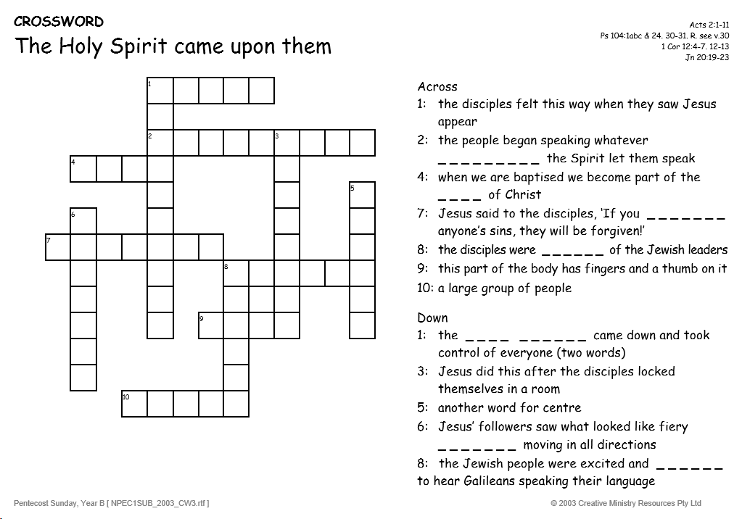

“My Lord and My God!”
Church & Parish Office: 5 Fiorelli Blvd, Cranbourne East 3977
Mailing address: PO Box 6089, Clyde VIC 3978
Parish Priest: Fr Denis O’Bryan Presbytery Phone: 5999 0059 (After office hours emergency)
Assistant Priest: Fr Jithin Anto
Deacon: Michael Manuel Email: Michael.Manuel@cdsale.org.au
Parish Office Hours: Tuesday – Friday 9.00am – 3.00pm
Parish Office Phone: 5998 0947
Email: parish@stthomasap.org.au Website: www.stthomasap.org.au www.facebook.com/stthomasap
Pastoral Associate: Sr Juliana Ogbole Email: clydenorth.pastoralassociate@cdsale.org.au
Parish Secretaries: Christine Salu Email: parish@stthomasap.org.au
Fiona Goh Email: Clydenorth.Secretary2@cdsale.org.au
Parish Safeguarding Officer: Ann Rode (Wednesday 9.00am – 3.00pm)
Email: Clydenorth.Safety@cdsale.org.au
WELCOME TO OUR MASS
Pentecost Sunday (Year B) – 19th May 2024
Masses & Reconciliation Times |  |  | Parish Schools
MASS CELEBRATED AT 5 FIORELLI BLVD CRANBOURNE EAST  Sunday Masses  Saturday Vigil: 6.00pm  Sunday: 9am, 10.45am & 5.00pm  Weekday Masses (week of 20th May –  20th May)  Monday & Tuesday - No Mass  Wednesday - Saturday: 9.30am | Baptism  Baptism Preparation 1st Sunday every month.  Sacrament of Baptism most Sundays.  Reconciliation  Every Friday & Saturday after morning Mass & Saturday between 5.30pm to 5.45pm.  Blessed Sacrament  24hrs except 1 hr before every Mass. Obtain access code from the Parish Office. |  | St Thomas the Apostle Primary School  5 Fiorelli Boulevard,  Cranbourne East  Phone: 5998 9293  Principal: Mrs Kate Dourley  St Peter’s Secondary College  (Clyde North Campus)  55 MacKillop Way, Clyde North  Phone: 5990 7777  Principal: Mr Chris Black

Prayer of Saint Thomas the Apostle
Glorious Saint Thomas, Your love for Jesus, and faith in Him as your Lord and God, are an inspiration for all who seek Jesus. You gave up your life for Him as an Apostle, and as a missionary. You encourage us to be courageous in giving witness to our faith and in proclaiming the Gospel. You lead us to be missionary in our endeavours. As our patron, pray for us as we build a new Catholic Church in Clyde North. We ask your intercession that we may spend ourselves in the service of Jesus and His mission. Under your watchful care may we grow in faith, and generously use our talents, gifts and vision in the service of Christ Jesus, and in love for our neighbour. St Thomas the Apostle Pray For Us

First Reading Acts 2:1-11
They were all filled with the Holy Spirit, and began to speak different languages.

The Word of the Lord
Responsorial Psalm Ps 103:1. 24. 29-31. 34
R. Lord, send out your Spirit and renew the face of the earth.

Bless the Lord, my soul!
Lord God, how great you are,
How many are your works, O Lord!
The earth is full of your riches. (R.)

You take back your spirit, they die,
returning to the dust from which they came.
You send forth your spirit, they are created
and you renew the face of the earth. (R.)

May the glory of the Lord last for ever!
May the Lord rejoice in his works!
May my thoughts be pleasing to him.
I find my joy in the Lord. (R.)

Second Reading 1 Cor 12:3-7, 12-13
In the one Spirit we were all baptised, making one body

The Word of the Lord
Gospel Acclamation
Alleluia, alleluia! Come, Holy Spirit, fill the hearts of your faithful and kindle in them the fire of your love. Alleluia!

Gospel John 20:19-23
As the Father sent me, so I send you: Receive the Holy Spirit.
In the evening of the first day of the week, the doors were closed in the room where the disciples were, for fear of the Jews. Jesus came and stood among them. He said to them, ‘Peace be with you,’ and showed them his hands and his side. The disciples were filled with joy when they saw the Lord, and he said to them again, ‘Peace be with you.‘As the Father sent me, so am I sending you.’ After saying this he breathed on them and said: ‘Receive the Holy Spirit. For those whose sins you forgive, they are forgiven; for those whose sins you retain, they are retained.’

The Gospel of the Lord.
Memorial Acclamation
When we eat this bread and drink this cup, we proclaim your death, O Lord, until you come again..

We kindly ask that you keep the house of GOD clean. No Food & Drinks in the Church and check that you have not left any belongings behind before leaving the Church.

Dear Parishioners,
This weekend we celebrate the Feast of Pentecost. It also is the weekend when Bishop Greg will lead the Sale Diocese in beginning a process of Consultation in the Diocese in preparation for a Diocesan Assembly to be held in February next year. I ask all parishioners to give every possible support to this process, both in prayer and active participation. The Parish Pastoral Council met during the week. The Parish Leadership urges all parishioners to support the coming process of Consultation.
The Parish Pastoral Council members, along with other parishioners who exercise leadership in parish groups, are currently participating in the Alpha Program. The Pastoral Council has scheduled a full Alpha Program, open to everyone, to be run in our parish between September and November this year.
The Pastoral Council also endorsed Fr Denis to share our vision for our parish at all Masses next weekend.
Amongst the priests of our diocese, Fr Peter Bickley this weekend (18th May) celebrates the Golden Jubilee of his Ordination. Congratulations Fr Peter. The Diocese has been richly blessed through your ministry.
After this weekend Fr Jithin will be taking his annual leave, returning near the end of June. We have been blessed to have him come to our parish this year, and we wish him a good holiday and a happy visit to his family in India.
On the first weekend in June the newly appointed Principal of St Josephine Bakhita Primary School, Kathryn Pepper, will be visiting all the weekend Masses.
Congratulations to all involved with the Procession last Sunday to crown Mary as Queen of May.
May God bless you all, Fr Denis.
NOTICES
NAME A NEW PARISH SCHOOL: Our parish currently has one Catholic Primary School, named St Thomas the Apostle, and our second school named St Josephine Bakhita is being built. We have a site near Clyde township for a third school to be built. It already has the name of St Dominic. A fourth Catholic Primary School is to be located between Clyde and Cardinia. It needs a name. We are seeking a female saints name to pair with St Dominic, so that we have two men and two women saints. Ultimately, Bishop Greg will choose the name but as a parish we would like to send him a shortlist of three names.
Please submit your suggestion in writing, with your reasons, to the parish office by Sunday 2nd June.
YOUNG ADULTS GROUP (YAG) for 18-35 YEARS: Next meeting Sunday 26th May 6.30-8.30pm. New members welcome! For further details, contact parish@stthomasap.org.au
SAFETRAC ONLINE TRAINING FOR PARISH STAFF AND VOLUNTEERS - As part of the Diocesan Safeguarding Policy released late last year, parish staff and volunteers are required to undertake Safeguarding training regularly. The Diocese has released an online training module. Staff and volunteers in our parish who have an email address will shortly receive an email link to complete the training. This training is completed every three years. Other arrangements are being made for volunteers who do not have emails or internet access. We ask for your cooperation to undertake this online training as soon as possible as part of our parish commitment to promoting a safe environment for our children, youth, and adults at risk.
RCIA in St Thomas the Apostle Parish. Our Parish RCIA Team needs new members. We have people enquiring about the Catholic faith, and some wanting to start their journey to become Catholics this year. This is a wonderful blessing for our parish, but we need extra help to accompany these enquirers. You may previously have been involved with the RCIA in another parish or may be just willing to assist the existing team members. We need you now! Please contact the Parish office.
RETREAT & DAY OF PRAYER - All Lectors and EM’s are invited to a Retreat and Day of Prayer with the theme "Food for the Journey" on Saturday 25th May from 11.30am to 3pm. It is very important in our ministry to nurture our spirits by gathering together for prayer and reflection. There will be registration sign-up sheets on the tables in the foyer and we ask that you use these to register so that we will have an idea of numbers for catering.
LEGION OF MARY GROUP MONTH OF MAY - Invitation to join us as we pray the Rosary every Thursday evening at 7pm in the church to honour Our Lady through the month of May.
THE POWER OF PENTECOST – Diocese Pentecost celebrations on 25th May. Further information Bro. Fernando on
0466 717 077 and/or Br. Lindsay D’Argent on 0432 375 391
DISCIPLESHIP RETREAT - For Children and Teens Ages 5-15. 25th & 26th May 9-3.30pm. Enrol at www.divinekids.com.au
LITTLE FRIENDS OF JESUS (LFJ) – Classes has resumed and new members welcome. Start 3.50pm every Saturday during the school term.
CONTRIBUTION FOR CHURCH FLOWERS – If you or anyone you know who can donate (loose) flowers or contribute money towards purchasing flowers for the church, please ring the Parish Office.
VOLUNTEERS REQUIRED FOR:
- PIETY SHOP – If you can operate the shop after the Sunday 10.45am Mass, please contact the Parish Office.

FUNERALS, WEDDINGS & OTHER EVENTS happening in the church please contact the parish office to express your interest. Training provided. Please contact the Parish Office.
NEW, RELOCATING or LEAVING THE PARISH?
New Parishioners – please register @ https://stthomasap.org.au/new-parishioner-registration/
Relocating or Leaving Parishioners – please call the parish office
DONATIONS TO THE CHURCH – TAP POINT TERMINALS: these donations are NOT combined with the Planned Giving Stewardship donations. To join or donate to the Planned Giving Stewardship Program please contact the parish office.
SAFEGUARDING – Please always supervise your child/ren in the church and in the toilets. Our parish is committed to providing a safe and supportive environment for all people with special concern for children, young people and adults at risk. Our Safeguarding Office, Ann Rode, can be contacted via email: clydenorth.safety@cdsale.org.au or call 5998 0947

\fdfdfdfdfdfdfdfdfListening and Discernment
The Plenary Council National Team is continuing working on this phase to present it to all parishes in Australia. We pray to the Spirit of
God to help with this preparation upholding the people of this country in his heart. www.plenarycouncil.com.au
Diocesan Pilgrimage held this week at St Ita’s Catholic Church in
Drouin
SALE DIOCESAN ASSEMBLY - 13
th
& 14
th
SEPTEMBER 2019
We invite all parishioners to join in a parish discussion and share your thoughts on the Themes for the Diocesan Assembly. Our parish
offers four ways in which we can join in the conversation:
1. Coming together on Monday 2
nd
of September at 7.30 pm – St Peter’s College. This main session is for Delegates attending the
Diocesan Assembly but also open to parishioners.
2. You might also wish to discuss the themes in small groups at home, with family and friends or in your prayer groups and submit your
thoughts online.
3. You may also send in your own personal submission online following the steps on the Diocese website.
4. Alternatively, you may wish to write your responses filling in your comments about a particular Assembly theme on the feedback form
called: “Share your thoughts with us! What would a parish living the joy of the gospel look like?” Copies of
this form are placed at the entrance tables. Please fill it in, bring your response to Mass and post it into the Parish Office Box placed
at the entrance table also.

All personal & group responses can be submitted to our Diocese website before the 9
th
September
The discussion kit is available from the Diocesan website
Diocese website : https://www.cdsale.org.au/news/
DIOCESAN ASSEMBLY THEMES
Reflecting on a theme: what would a parish living the joy of the Gospel be
like?
Theme 1: Faith Formation & Spirituality, which involves • Faith Formation for adults • Faith formation for children and young people •
Sacramental Preparation • RCIA • Understanding Church Teaching • Prayer life
Theme 2: Leadership & Governance (providing leadership & structures that promote evangelisation) • National/diocesan/parish
structures • Finance matters • Parish Pastoral Councils • Ongoing support, mentoring and professional development of leaders and staff
• Pastoral Planning • Communication • Roles – priests, religious, laity.
Theme 3: Families and Vocation (raising disciples in our families - so that they can go out into the world) • Supporting family life in all
its diversity • Supporting married couples • Supporting young people/young adults • Vocations.
Theme 4: Liturgy and Prayer (nourishing our communities) • Music • Homilies • Liturgical formation for parish communities and liturgy
teams • Liturgies, other than Sunday Eucharist • A variety of prayer experiences
Theme 5: The Welcoming Community (a community on mission, not maintenance) • Building a welcoming community • Pastoral care •
Reaching out to those on the margins (divorced and remarried, gay community, those with disabilities) • Reaching out to those who have
left the church (resting Catholics) • Strategies for growing parishes • Caring for those affected by the sexual abuse crisis
All personal & group responses can be submitted to our Diocese before the 9
th
September
Diocese website : https://www.cdsale.org.au/news/
We thank you for your time and your thoughts. May God bless you!

