Groups and Meetings
BAPTISM PREPARATION: 1st Sunday of the month 2.00pm for more information or registration call the Parish Office or visit our website.
MARRIAGES: At least 6 months’ notice. Call the Parish Office
RCIA: For adults interested to join the Catholic Faith. Classes to begin soon. For enquiries, contact Ruth Marais on 0430 716 664.
SACRAMENT FOR SCHOOL AGED CHILDREN (1st Reconciliation, 1st Holy Communion & Confirmation) :
Email parishofstthomasap@gmail.com
LITTLE FRIENDS OF JESUS – teaching of the catholic faith to children from Prep – Gr 6. Every Saturday (school term) 4pm email: friendsofjesussttap@gmail.com
YOUNG ADULT GROUP: Ages: 18-35 years. For enquiries, please contact the Parish Office.
ST VINNIES PHONE ROOM – if you or someone you know need assistance from St Vinnies, please call 5995 0211.
LEGION OF MARY PRAESIDIUM – For enquiries or to express your interest, please call Mary on 0432 166 850 or the Parish Office

Mass Intentions  Saturday (25/5) 6.00pm : People of the parish  Sunday (26/5 ) 9.00am : Repose of the soul of Robert Orchard  10.45am : Repose of the soul of Kevin O’Bryan  5.00pm : Thanksgiving Mass - Estorco Family  Monday (27/5) : No Mass  Tuesday (28/5) : Repose of the Soul of Sylvaine Vivier  Wednesday (29/5) : Repose of the Soul of Joy Abraham Soni & Narayanasamy  Thursday (30/5) : No Mass  Friday (31/5) : Nimanthi & Chaminda Family(for protection of the home)  Saturday (1/6) : No Mass  Pray for the sick: : Fr Bernard Buckley, Luicile Noel, Sue Dower, Salvador Guidos, Albert Hartung, Greg Recalde, Carol Vincenz, Anura Fernando, Ross Smith, Clermont Ignace, John Stray, Gillian Apollon, Jean Camilleri, George Bester, Elena Laugalis, Marsha Mushonga, Bill Reymers, Rita Sciculna, Euphenia Noyahr, Fr. Andrew Wise, Jeyden Kamau, Shireen Chater  Death Anniv/Remb : Telesia Fatialofa, Joe Candappa, Winston Thompson & deceased clergy of the Diocese of Sale |  | Parish Council Members:  Fr Denis, Dcn Michael, Jonathan Rubite, Sandra Ignace, Dezlene Orchard, Jerusha Benjamin,  Parish Finance Members: Fr Denis, Sinclair Thomas, Patrick Ross, Helene Jayamaha, Peter Gomez, Heidi Keel, Ruwan Kumaraperu

New Parishioner Registration
Please register online at https://stthomasap.org.au/new-parishioner-registration/
OR pick up a form from our worship space OR call the Parish Office

SUNDAY ACTIVITY (more activity sheets for children, teens and young adults available in the foyer)
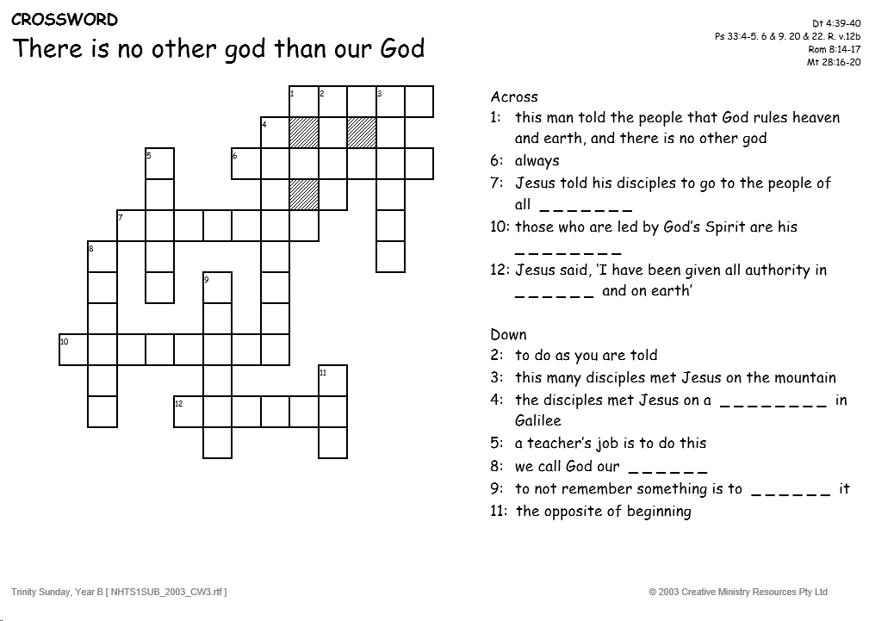

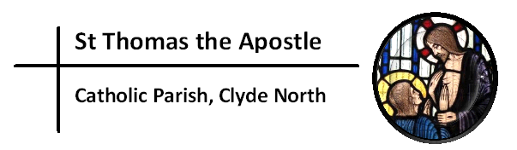
“My Lord and My God!”
Church & Parish Office: 5 Fiorelli Blvd, Cranbourne East 3977
Mailing address: PO Box 6089, Clyde VIC 3978
Parish Priest: Fr Denis O’Bryan Presbytery Phone: 5999 0059 (After office hours emergency)
Assistant Priest: Fr Jithin Anto
Deacon: Michael Manuel Email: Michael.Manuel@cdsale.org.au
Parish Office Hours: Tuesday – Friday 9.00am – 3.00pm
Parish Office Phone: 5998 0947
Email: parish@stthomasap.org.au Website: www.stthomasap.org.au www.facebook.com/stthomasap
Pastoral Associate: Sr Juliana Ogbole Email: clydenorth.pastoralassociate@cdsale.org.au
Parish Secretaries: Christine Salu Email: parish@stthomasap.org.au
Fiona Goh Email: Clydenorth.Secretary2@cdsale.org.au
Parish Safeguarding Officer: Ann Rode (Wednesday 9.00am – 3.00pm)
Email: Clydenorth.Safety@cdsale.org.au
WELCOME TO OUR MASS
Trinity Sunday (Year B) – 26th May 2024
Masses & Reconciliation Times |  |  | Parish Schools
MASS CELEBRATED AT 5 FIORELLI BLVD CRANBOURNE EAST  Sunday Masses  Saturday: 6pm  Sunday: 9am, 10.45am & 5.00pm  Weekday Masses  (week of 27th^{th} May – ^{1st} June)  Monday: No Mass  Tuesday: 9.30am  Wednesday: 9.30am  Thursday: No Mass  Friday: 9.30am  Saturday: No Morning Mass  Feast & Memorial  The Visitation of the Blessed Virgin Mary  St Justin, martyr | Baptism  Baptism Preparation 1st Sunday of every month.  Sacrament of Baptism most Sundays.  Reconciliation  Every Friday & Saturday after morning Mass & Saturday between 5.30pm to 5.45pm.  Blessed Sacrament  24hrs except 1 hr before every Mass. Obtain access code from the Parish Office. |  | St Thomas the Apostle Primary School  5 Fiorelli Boulevard,  Cranbourne East  Phone: 5998 9293  Principal: Mrs Kate Dourley  St Peter’s Secondary College  (Clyde North Campus)  55 MacKillop Way, Clyde North  Phone: 5990 7777  Principal: Mr Chris Black
Prayer of Saint Thomas the Apostle
Glorious Saint Thomas, Your love for Jesus, and faith in Him as your Lord and God, are an inspiration for all who seek Jesus. You gave up your life for Him as an Apostle, and as a missionary. You encourage us to be courageous in giving witness to our faith and in proclaiming the Gospel. You lead us to be missionary in our endeavours. As our patron, pray for us as we build a new Catholic Church in Clyde North. We ask your intercession that we may spend ourselves in the service of Jesus and His mission. Under your watchful care may we grow in faith, and generously use our talents, gifts and vision in the service of Christ Jesus, and in love for our neighbour. St Thomas the Apostle Pray For Us

First Reading Deuteronomy 4:32-34,39-40
The Lord is God indeed: he and no other

The Word of the Lord
Responsorial Psalm Ps 32(33):4-6,9,18-20,22
R. Happy the people the Lord has chosen to be his own.

By his word the heavens were made,
by the breath of his mouth all the stars.
He spoke; and it came to be.
He commanded; it sprang into being.

The Lord looks on those who revere him,
on those who hope in his love,
to rescue their souls from death,
to keep them alive in famine.

Our soul is waiting for the Lord.
The Lord is our help and our shield.
May your love be upon us, O Lord,
as we place all our hope in you.

Second Reading Romans 8:14-17
The Spirit himself and our spirit bear united witness that we are children of God

The Word of the Lord
Gospel Acclamation Revelation 1:8
Alleluia, alleluia! Glory to the Father, the Son, and the Holy Spirit: to God who is, who was, and who is to come. Alleluia!

Gospel Matthew 28:16-20
Go and make disciples of all nations
The eleven disciples set out for Galilee, to the mountain where Jesus had arranged to meet them. When they saw him they fell down before him, though some hesitated. Jesus came up and spoke to them. He said, ‘All authority in heaven and on earth has been given to me. Go, therefore, make disciples of all the nations; baptise them in the name of the Father and of the Son and of the Holy Spirit, and teach them to observe all the commands I gave you. And know that I am with you always; yes, to the end of time.’

The Gospel of the Lord.
Memorial Acclamation
Save us, Savior of the world, for by your cross and resurrection you have set us free.

NOTICES

NAME A NEW PARISH SCHOOL: Our parish currently has one Catholic Primary School, named St Thomas the Apostle, and our second school named St Josephine Bakhita is being built. We have a site near Clyde township for a third school to be built. It already has the name of St Dominic. A fourth Catholic Primary School is to be located between Clyde and Cardinia. It needs a name. We are seeking a female saints name to pair with St Dominic, so that we have two men and two women saints. Ultimately, Bishop Greg will choose the name but as a parish we would like to send him a shortlist of three names. Please submit your suggestion in writing, with your reasons, to the parish office by Sunday 2nd June.
ALPHA in St Thomas the Apostle Parish - Help us share the ultimate gift of Hope. Alpha is offered free to everyone, but it comes as a cost to the parish. Your generosity helps support the running of this program in our parish and in turn will transform lives. Please contact the Parish Office for more information or donation.
SAFETRAC ONLINE TRAINING FOR PARISH STAFF AND VOLUNTEERS - As part of the Diocesan Safeguarding Policy released late last year, parish staff and volunteers are required to undertake Safeguarding training regularly. The Diocese has released an online training module. Staff and volunteers in our parish who have an email address will shortly receive an email link to complete the training. This training is completed every three years. Other arrangements are being made for volunteers who do not have emails or internet access. We ask for your cooperation to undertake this online training as soon as possible as part of our parish commitment to promoting a safe environment for our children, youth, and adults at risk.
RCIA in St Thomas the Apostle Parish. Our Parish RCIA Team needs new members. We have people enquiring about the Catholic faith, and some wanting to start their journey to become Catholics this year. This is a wonderful blessing for our parish, but we need extra help to accompany these enquirers. You may previously have been involved with the RCIA in another parish or may be just willing to assist the existing team members. We need you now! Please contact the Parish office.
NATIONAL PILGRAMAGE: "In the Footsteps of Mary MacKillop" pilgrimage is led and run by the Sisters of Saint Joseph of the Sacred Heart. 15th - 26th of October 2024. A unique opportunity for individuals and families to come together in prayer, reflection, and celebration of Mary MacKillop's life and teachings. A deeply enriching and spiritually fulfilling experience for all who attend. Contact (02) 8912 4818 Email: national.pilgrimage@mmp.org.au or visit www.marymackillopplace.org.au
SPIRITUAL RENEWAL MINISTRY (SRM) - NON STOP 24HRS BIBLE READING. At OLHC Parish Narre warren.
on 9TH to 10TH of June 2024. Please call to book your reading time!!! Frenco - 0413 519 863 or Rony K – 0421 125 239
LITTLE FRIENDS OF JESUS (LFJ) – Classes has resumed and new members welcome. Start 3.50pm every Saturday during the school term.
CONTRIBUTION FOR CHURCH FLOWERS – If you or anyone you know who can donate (loose) flowers or contribute money towards purchasing flowers for the church, please ring the Parish Office.
VOLUNTEERS REQUIRED FOR:
- PIETY SHOP – If you can operate the shop after the Sunday 10.45am Mass, please contact the Parish Office.

FUNERALS, WEDDINGS & OTHER EVENTS happening in the church please contact the parish office to express your interest. Training provided. Please contact the Parish Office.

NEW, RELOCATING or LEAVING THE PARISH?
New Parishioners – please register @ https://stthomasap.org.au/new-parishioner-registration/
Relocating or Leaving Parishioners – please call the parish office
DONATIONS TO THE CHURCH – TAP POINT TERMINALS: these donations are NOT combined with the Planned Giving Stewardship donations. To join or donate to the Planned Giving Stewardship Program please contact the parish office.
SAFEGUARDING – Please always supervise your child/ren in the church and in the toilets. Our parish is committed to providing a safe and supportive environment for all people with special concern for children, young people and adults at risk. Our Safeguarding Office, Ann Rode, can be contacted via email: clydenorth.safety@cdsale.org.au or call 5998 0947

We kindly ask that you keep the house of GOD clean. No Food & Drinks in the Church and check that you have not left any belongings behind before leaving Church.

\fdfdfdfdfdfdfdfdfListening and Discernment
The Plenary Council National Team is continuing working on this phase to present it to all parishes in Australia. We pray to the Spirit of
God to help with this preparation upholding the people of this country in his heart. www.plenarycouncil.com.au
Diocesan Pilgrimage held this week at St Ita’s Catholic Church in
Drouin
SALE DIOCESAN ASSEMBLY - 13
th
& 14
th
SEPTEMBER 2019
We invite all parishioners to join in a parish discussion and share your thoughts on the Themes for the Diocesan Assembly. Our parish
offers four ways in which we can join in the conversation:
1. Coming together on Monday 2
nd
of September at 7.30 pm – St Peter’s College. This main session is for Delegates attending the
Diocesan Assembly but also open to parishioners.
2. You might also wish to discuss the themes in small groups at home, with family and friends or in your prayer groups and submit your
thoughts online.
3. You may also send in your own personal submission online following the steps on the Diocese website.
4. Alternatively, you may wish to write your responses filling in your comments about a particular Assembly theme on the feedback form
called: “Share your thoughts with us! What would a parish living the joy of the gospel look like?” Copies of
this form are placed at the entrance tables. Please fill it in, bring your response to Mass and post it into the Parish Office Box placed
at the entrance table also.

All personal & group responses can be submitted to our Diocese website before the 9
th
September
The discussion kit is available from the Diocesan website
Diocese website : https://www.cdsale.org.au/news/
DIOCESAN ASSEMBLY THEMES
Reflecting on a theme: what would a parish living the joy of the Gospel be
like?
Theme 1: Faith Formation & Spirituality, which involves • Faith Formation for adults • Faith formation for children and young people •
Sacramental Preparation • RCIA • Understanding Church Teaching • Prayer life
Theme 2: Leadership & Governance (providing leadership & structures that promote evangelisation) • National/diocesan/parish
structures • Finance matters • Parish Pastoral Councils • Ongoing support, mentoring and professional development of leaders and staff
• Pastoral Planning • Communication • Roles – priests, religious, laity.
Theme 3: Families and Vocation (raising disciples in our families - so that they can go out into the world) • Supporting family life in all
its diversity • Supporting married couples • Supporting young people/young adults • Vocations.
Theme 4: Liturgy and Prayer (nourishing our communities) • Music • Homilies • Liturgical formation for parish communities and liturgy
teams • Liturgies, other than Sunday Eucharist • A variety of prayer experiences
Theme 5: The Welcoming Community (a community on mission, not maintenance) • Building a welcoming community • Pastoral care •
Reaching out to those on the margins (divorced and remarried, gay community, those with disabilities) • Reaching out to those who have
left the church (resting Catholics) • Strategies for growing parishes • Caring for those affected by the sexual abuse crisis
All personal & group responses can be submitted to our Diocese before the 9
th
September
Diocese website : https://www.cdsale.org.au/news/
We thank you for your time and your thoughts. May God bless you!

