Groups and Meetings
BAPTISM PREPARATION: 1st Sunday of the month 2.00pm for more information or registration call the Parish Office or visit our website.
MARRIAGES: At least 6 months’ notice. Call the Parish Office
RCIA: For adults interested to join the Catholic Faith. Classes to begin soon. For enquiries, contact Ruth Marais on 0430 716 664.
SACRAMENT FOR SCHOOL AGED CHILDREN (1st Reconciliation, 1st Holy Communion & Confirmation) :
Email parishofstthomasap@gmail.com
LITTLE FRIENDS OF JESUS – teaching of the catholic faith to children from Prep – Gr 6. Every Saturday (school term) 4pm email: friendsofjesussttap@gmail.com
YOUNG ADULT GROUP: Ages: 18-35 years. For enquiries, please contact the Parish Office.
ST VINNIES PHONE ROOM – if you or someone you know need assistance from St Vinnies, please call 5995 0211.
LEGION OF MARY PRAESIDIUM – For enquiries or to express your interest, please call Mary on 0432 166 850 or the Parish Office

Mass Intentions  Saturday (4/5) 6.00pm : Repose of the souls of Aristoteles Ilarde & Pacita dela Cruz  Sunday (5/5 ) 9.00am : Thanksgiving Mass for the Crasto family  10.45am : Repose of the souls of Maseiga & Kelston Tuala  5.00pm : People of the parish  Monday (6/5) : No Mass  Tuesday (7/5) : Thanksgiving Mass from the Salu family  Wednesday (8/5) : Repose of the soul of Gabriel Goh  Thursday (9/5) : Repose of the soul of Philo Davids & pray for good health & b’day blessing for Cecilia Ross  Friday (10/5) : Repose of the souls of Franc & Lise Donaldson  Saturday (11/5) : Repose of the soul of Celia Canoy (Anniv)  Pray for the sick: : Fr Bernard Buckley, Luicile Noel, Sue Dower, Salvador Guidos, Albert Hartung, Greg Recalde, Carol Vincenz, Anura Fernando, Ross Smith, Clermont Ignace, John Stray, Gillian Apollon, Jean Camilleri, George Bester, Elena Laugalis, Marsha Mushonga, Bill Reymers, Rita Sciculna  Death Anniv/Remb : Felipe Jaboli, Walter De Silva, Ligoury D’Souza, Severine Pinto, Claudette & Leslie Sinclair, Moira & Albert Simmons, France Wangyuen, Lucette Gnany & deceased clergy of the Diocese of Sale |  | Parish Council Members:  Fr Denis, Dcn Michael, Jonathan Rubite, Sandra Ignace, Dezlene Orchard, Jerusha Benjamin,  Parish Finance Members: Fr Denis, Sinclair Thomas, Patrick Ross, Helene Jayamaha, Peter Gomez, Heidi Keel, Ruwan Kumaraperu

Next week’s readings: Acts 1:1-11 Eph 4: 1-13 Mark 16:15-20

New Parishioner Registration
Please register online at https://stthomasap.org.au/new-parishioner-registration/
OR pick up a form from our worship space OR call the Parish Office

SUNDAY ACTIVITY (more activity sheets for children, teens and young adults available in the foyer)
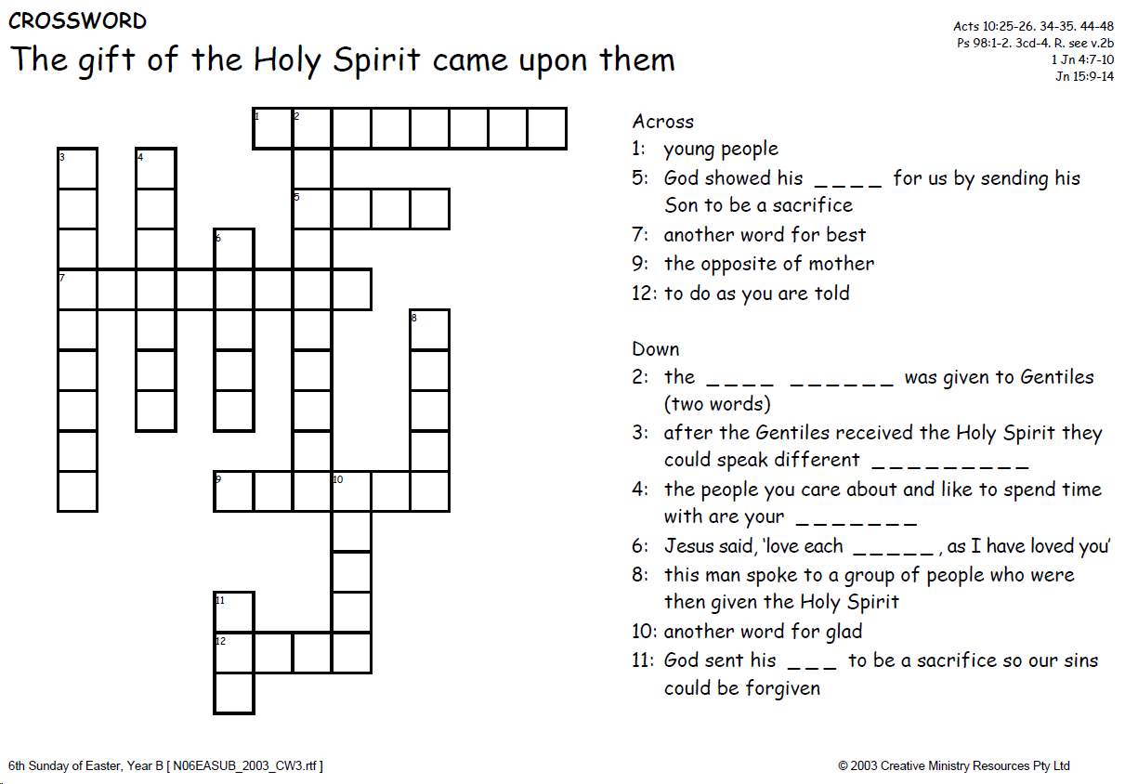
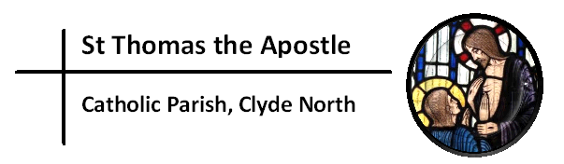
“My Lord and My God!”
Church & Parish Office: 5 Fiorelli Blvd, Cranbourne East 3977
Mailing address: PO Box 6089, Clyde VIC 3978
Parish Priest: Fr Denis O’Bryan Presbytery Phone: 5999 0059 (After office hours emergency)
Assistant Priest: Fr Jithin Anto
Deacon: Michael Manuel Email: Michael.Manuel@cdsale.org.au
Parish Office Hours: Tuesday – Friday 9.00am – 3.00pm
Parish Office Phone: 5998 0947
Email: parish@stthomasap.org.au Website: www.stthomasap.org.au www.facebook.com/stthomasap
Pastoral Associate: Sr Juliana Ogbole Email: clydenorth.pastoralassociate@cdsale.org.au
Parish Secretaries: Christine Salu Email: parish@stthomasap.org.au
Fiona Goh Email: Clydenorth.Secretary2@cdsale.org.au
Parish Safeguarding Officer: Ann Rode (Wednesday 9.00am – 3.00pm)
Email: Clydenorth.Safety@cdsale.org.au
WELCOME TO OUR MASS
6th Sunday of Easter (Year B) – 5th May 2024
Masses & Reconciliation Times |  |  | Parish Schools
MASS CELEBRATED AT 5 FIORELLI BLVD CRANBOURNE EAST  Sunday Masses  Saturday Vigil: 6.00pm  Sunday: 9am, 10.45am & 5.00pm  Weekday Masses (week of 6th May – 11th May)  Monday: No Mass  Tuesday - Saturday: 9.30am | Baptism  Baptism Preparation 1st Sunday every month.  Sacrament of Baptism most Sundays.  Reconciliation  Every Friday & Saturday after morning Mass & Saturday between 5.30pm to 5.45pm.  Blessed Sacrament  24hrs except 1 hr before every Mass. Obtain access code from the Parish Office. |  | St Thomas the Apostle Primary School  5 Fiorelli Boulevard,  Cranbourne East  Phone: 5998 9293  Principal: Mrs Kate Dourley  St Peter’s Secondary College  (Clyde North Campus)  55 MacKillop Way, Clyde North  Phone: 5990 7777  Principal: Mr Chris Black

Prayer of Saint Thomas the Apostle
Glorious Saint Thomas, Your love for Jesus, and faith in Him as your Lord and God, are an inspiration for all who seek Jesus. You gave up your life for Him as an Apostle, and as a missionary. You encourage us to be courageous in giving witness to our faith and in proclaiming the Gospel. You lead us to be missionary in our endeavours. As our patron, pray for us as we build a new Catholic Church in Clyde North. We ask your intercession that we may spend ourselves in the service of Jesus and His mission. Under your watchful care may we grow in faith, and generously use our talents, gifts and vision in the service of Christ Jesus, and in love for our neighbour. St Thomas the Apostle Pray For Us

First Reading Acts 10:25-26, 34-35,44-48
The pagans have received the Holy Spirit just as much as we have

The Word of the Lord
Responsorial Psalm Ps 97(98):1-4
R. The Lord has revealed to the nations his saving power.

Sing a new song to the Lord
for he has worked wonders.
His right hand and his holy arm
have brought salvation. R.

The Lord has made known his salvation;
has shown his justice to the nations.
He has remembered his truth and love
for the house of Israel. R.

All the ends of the earth have seen
the salvation of our God.
Shout to the Lord, all the earth,
ring out your joy. R.

Second Reading 1 John 4:7-10
Let us love one another, since love comes from God

The Word of the Lord
Gospel Acclamation
Alleluia, alleluia! All who love me will keep my words, and my Father will love them and we will come to them. Alleluia!
Gospel John 15:9-17
You are my friends if you do what I command you
Jesus said to his disciples:
‘As the Father has loved me, so I have loved you. Remain in my love. If you keep my commandments you will remain in my love, just as I have kept my Father’s commandments and remain in his love. I have told you this so that my own joy may be in you and your joy be complete. This is my commandment: love one another, as I have loved you. A man can have no greater love than to lay down his life for his friends. You are my friends, if you do what I command you. I shall not call you servants any more, because a servant does not know his master’s business; I call you friends, because I have made known to you everything I have learnt from my Father. You did not choose me: no, I chose you; and I commissioned you to go out and to bear fruit, fruit that will last; and then the Father will give you anything you ask him in my name.
What I command you is to love one another.’

The Gospel of the Lord.
Memorial Acclamation
When we eat this Bread and drink this Cup, we proclaim your Death, O Lord, until you come again.

NOTICES

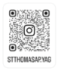
YOUNG ADULTS GROUP (YAG) for 18-35 YEARS: We are now on instagram stthomasap.yag For further details, contact parish@stthomasap.org.au. New young adults welcome.

DOMESTIC VIOLENCE - WHAT JESUS HAS TO SAY.
When Jesus says, “love one another as I have loved you” (John 15:9-17) there is no room for violence of any form. Yet many in our communities experience the pain of physical violence, control, and manipulation. Pretending ignorance of, or even enabling, such violence is clearly wrong and cowardly. We pray that we and our community may stand for victim survivors of domestic violence. For information: https://www.cdsale.org.au/sal
TRINITY FAMILIES MAY 2024 APPEAL - BISHOP Greg Bennet has urged the members of the diocese to generously support the annual appeal for Trinity Families, in our parishes this year. You can use the link to donate:
https://sale.cdfpay.org.au/details/?id=622462 or there will be a collection on the 18/19th June. Those wanting a receipt for taxation purposes are asked to use the envelopes available in the church foyer.
PROCESSION TO CROWN MARY, QUEEN OF MAY - Sunday 12th May after the 10.45am Mass. We appeal for parents to register their children aged 6-12 yrs old to carry flowers in the procession (flowers provided). Please note that parents must always stay with their child/ren. Statue of Mary will be carried around the carpark while praying the rosary and singing hymns. Clipboards available after all Masses on the weekend to register so that we can purchase the correct amount of flowers. Only parent’s name required.
ALPHA in St Thomas the Apostle Parish
Help us share the ultimate gift of Hope. Alpha is offered free to everyone, but it comes as a cost to the parish. Your generosity helps support the running of this program in our parish and in turn will transform lives. Please contact the Parish Office for more information or donation.
RCIA in St Thomas the Apostle Parish.
Our Parish RCIA Team needs new members.
We have people enquiring about the Catholic faith, and some wanting to start their journey to become Catholics this year. This is a wonderful blessing for our parish, but we need extra help to accompany these enquirers.
You may previously have been involved with the RCIA in another parish or may be just willing to assist the existing team members. We need you now! Please contact the Parish office.

RCIA MYSTAGOGIA MASS - SATURDAY 11th MAY 6PM MASS.- The Mystagogia Mass will be celebrated by Bishop Greg Bennet in our church on the 11th of May. Amongst our church community and Mass attendees on this day are the newly baptised Catholics, adults who were received into the full communion of the Catholic faith and others who completed their Christian Initiation at the Easter Vigil celebration & their families & sponsors from across parishes from the Diocese of Sale. Our very own parishioners, newly Confirmed brother & sisters Fritz Laguador, Piwai Kahonde, Irma Berciano and Shenali Perera, will also participate and celebrate at this Mass of Thanksgiving. Please keep them in prayer as they began their post baptismal catechesis - ‘mystagogia' - in the light of the Holy Spirit. May they continue to deepen their grasp of the paschal mystery and live the faith through meditation on the Gospel, sharing in the Eucharist and doing works of charity. Please bring a plate to share in this celebration and give our visitors a warm welcome to our parish. All are welcome.
RETREAT & DAY OF PRAYER - All Lectors and EM’s are invited to a Retreat and Day of Prayer with the theme "Food for the Journey" on Saturday 25th May from 11.30am to 3pm. It is very important in our ministry to nurture our spirits by gathering together for prayer and reflection. There will be registration sign-up sheets on the tables in the foyer and we ask that you use these to register so that we will have an idea of numbers for catering.
LEGION OF MARY GROUP MONTH OF MAY
Invitation to join us as we pray the Rosary every Thursday evening at 7pm in the church to honour Our Lady through the month of May. This begins from Thursday 9th May.
LITTLE FRIENDS OF JESUS (LFJ) – Classes has resumed and new members welcome. Start 3.50pm every Saturday during the school term.
CONTRIBUTION FOR CHURCH FLOWERS – If you or anyone you know who can donate (loose) flowers or contribute money towards purchasing flowers for the church, please ring the Parish Office.
VOLUNTEERS REQUIRED FOR:
- PIETY SHOP – If you can operate the shop after the Sunday 10.45am Mass, please contact the Parish Office.

FUNERALS, WEDDINGS & OTHER EVENTS happening in the church please contact the parish office to express your interest. Training provided. Please contact the Parish Office.
NEW, RELOCATING or LEAVING THE PARISH?
New Parishioners – please register @ https://stthomasap.org.au/new-parishioner-registration/
Relocating or Leaving Parishioners – please call the parish office
DONATIONS TO THE CHURCH – TAP POINT TERMINALS: these donations are NOT combined with the Planned Giving Stewardship donations. To join or donate to the Planned Giving Stewardship Program please contact the parish office.
SAFEGUARDING – Please always supervise your child/ren in the church and in the toilets. Our parish is committed to providing a safe and supportive environment for all people with special concern for children, young people and adults at risk. Our Safeguarding Office, Ann Rode, can be contacted via email: clydenorth.safety@cdsale.org.au or call 5998 0947
We kindly ask that you keep the house of GOD clean. No Food & Drinks in the Church and check that you have not left any belongings behind before leaving Church.

\fdfdfdfdfdfdfdfdfListening and Discernment
The Plenary Council National Team is continuing working on this phase to present it to all parishes in Australia. We pray to the Spirit of
God to help with this preparation upholding the people of this country in his heart. www.plenarycouncil.com.au
Diocesan Pilgrimage held this week at St Ita’s Catholic Church in
Drouin
SALE DIOCESAN ASSEMBLY - 13
th
& 14
th
SEPTEMBER 2019
We invite all parishioners to join in a parish discussion and share your thoughts on the Themes for the Diocesan Assembly. Our parish
offers four ways in which we can join in the conversation:
1. Coming together on Monday 2
nd
of September at 7.30 pm – St Peter’s College. This main session is for Delegates attending the
Diocesan Assembly but also open to parishioners.
2. You might also wish to discuss the themes in small groups at home, with family and friends or in your prayer groups and submit your
thoughts online.
3. You may also send in your own personal submission online following the steps on the Diocese website.
4. Alternatively, you may wish to write your responses filling in your comments about a particular Assembly theme on the feedback form
called: “Share your thoughts with us! What would a parish living the joy of the gospel look like?” Copies of
this form are placed at the entrance tables. Please fill it in, bring your response to Mass and post it into the Parish Office Box placed
at the entrance table also.

All personal & group responses can be submitted to our Diocese website before the 9
th
September
The discussion kit is available from the Diocesan website
Diocese website : https://www.cdsale.org.au/news/
DIOCESAN ASSEMBLY THEMES
Reflecting on a theme: what would a parish living the joy of the Gospel be
like?
Theme 1: Faith Formation & Spirituality, which involves • Faith Formation for adults • Faith formation for children and young people •
Sacramental Preparation • RCIA • Understanding Church Teaching • Prayer life
Theme 2: Leadership & Governance (providing leadership & structures that promote evangelisation) • National/diocesan/parish
structures • Finance matters • Parish Pastoral Councils • Ongoing support, mentoring and professional development of leaders and staff
• Pastoral Planning • Communication • Roles – priests, religious, laity.
Theme 3: Families and Vocation (raising disciples in our families - so that they can go out into the world) • Supporting family life in all
its diversity • Supporting married couples • Supporting young people/young adults • Vocations.
Theme 4: Liturgy and Prayer (nourishing our communities) • Music • Homilies • Liturgical formation for parish communities and liturgy
teams • Liturgies, other than Sunday Eucharist • A variety of prayer experiences
Theme 5: The Welcoming Community (a community on mission, not maintenance) • Building a welcoming community • Pastoral care •
Reaching out to those on the margins (divorced and remarried, gay community, those with disabilities) • Reaching out to those who have
left the church (resting Catholics) • Strategies for growing parishes • Caring for those affected by the sexual abuse crisis
All personal & group responses can be submitted to our Diocese before the 9
th
September
Diocese website : https://www.cdsale.org.au/news/
We thank you for your time and your thoughts. May God bless you!

